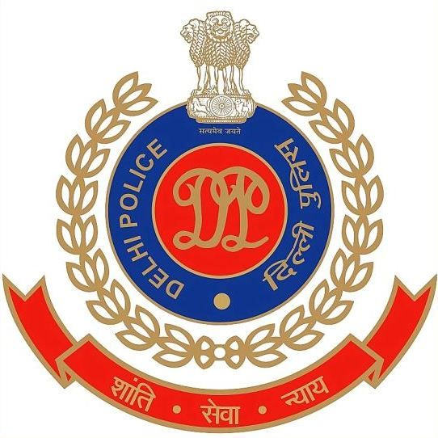
OFFICE OF THE STATION HOUSE OFFICER, CYBER POLICE STATION, NORTH DISTRICT, DELHI, INDIA

Assistant Commissioner of Police Operations Office Complex,
Behind Daulat Ram College, Maurice Nagar, Delhi-110007, INDIA
EMAIL: - shocyber.north@delhipolice.gov.in (Mob No.) +916828402037
No. Cyber Police Station, North Delhi, Dated the / /2026
To,
Legal Operation / Risk / Security / Nodal Head
<Bank Name >
Subject: - Action required U/s 94 BNSS ACK No. < > for CCTV Footage PS Cyber, North District, Delhi. (Strictly Confidential)
A complaint has been received on the NCRP Cyber Portal regarding cheating under various Acknowledgement No. Upon preliminary inquiry, it was found that certain fraudulent transactions were carried out through the given ATM ID and bank account details mentioned below:
Acknowledgement No. | ATM ID | Bank | form Date and Time of Withdrawal | TO Date and Time of Withdrawal
32107260034851 | 40142SRY | ICICI Bank | 14/07/2026 16:27 | 14/07/2026 16:30
32907260052445 | U1BC000691022 | State Bank of India | 19/07/2026 23:19 | 19/07/2026 23:25
32707260075614 | S1ANDD73 | HDFC Bank | 20/07/2026 16:8 | 20/07/2026 16:41
31107260164659 | S1NW017036131 | State Bank of India | 14/07/2026 18:29 | 14/07/2026 18:33
31907260154174 | SCRD02881S | Central Bank of India | 15/07/2026 11:32 | 15/07/2026 11:36
32907260052837 | OA0351S1 | Bank of Maharashtra | 16/07/2026 17:50 | 16/07/2026 17:54
Action Required:
1. To provide certificate U/s 2A of banker’s book evidence act, 1891 for the documents.
2. Please provide downloadable CCTV footage for the above-mentioned ATM ID, date, and time, including coverage of both inside and outside the ATM, for 5 minutes before and 5 minutes after the specified time as detailed below:
3. Any additional pertinent information that may aid in our ongoing inquiry.
4. Provide the contact number/Email id of the concerned Nodal Officer who provides ATM footage.

HC Rajendra Kumar
PS Cyber/North, Delhi
Email: shocyber.north@delhipolice.gov.in
Mobile: +91-9818036472

